+91 9888925521



1 77777 66666

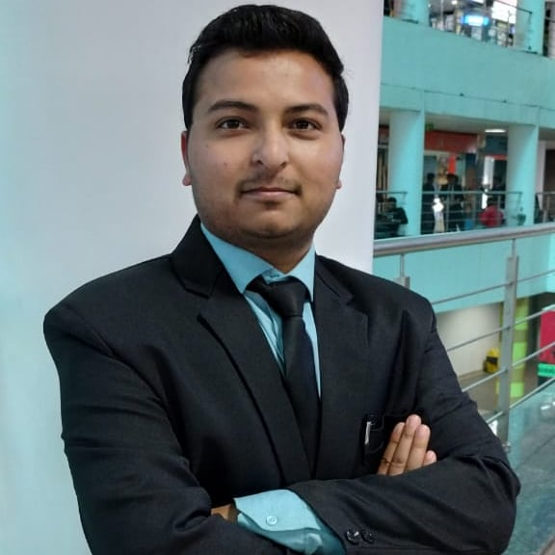

Avinashpandey2492002@gmail.com

Avinash Pandey

avinash-pandey-8295291b5



Full Stack Developer

[Avi2492](https://sdgjekxzr/)

Ludhiana, Punjab



SUMMARY

Motivated student pursuing B.Tech Computer Science and Engineering degree. Supports team administrative, project coordination, design and programming needs.

TECHNICAL SKILLS

**Programming languages**: Java, JavaScript, Python, C++ .

**Frameworks**:

jQuery, Bootstrap5, HTML5, CSS

**Another Skills**:

Photoshop, Wordpress

**Data Base**: Oracle.

**Tools**: VS code, Net -beans, re-plit.

LANGUAGES

* English
* Hindi

POWER SKILLS

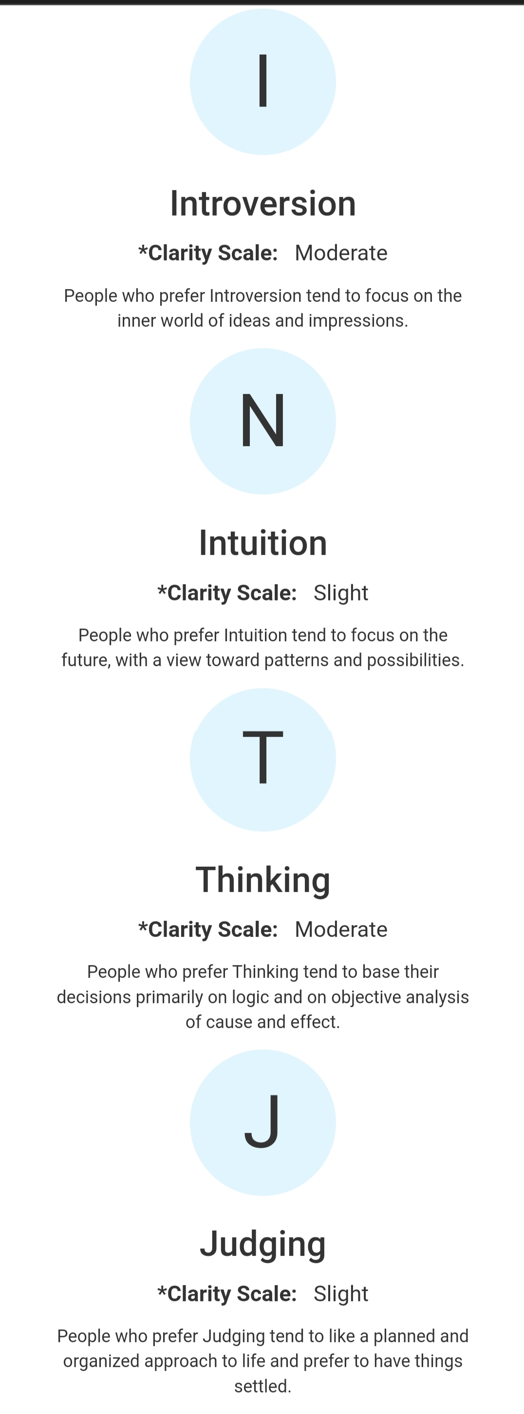

EXTRA CURRICULAR ACTIVITIES

Java - Essential Programming – workshop Lets Upgrade Feb'23 Python - Essential Programming – workshop Lets Upgrade Dec'22

INTERNSHIP AND TRAININGS

**C++ Summer Training** May '22 - Jun '22 Great Learning

Programming & Project

Gained hands-on experience in developing, implementing, and maintaining software Development projects.

**Data Structures and algorithms Winter Training** Sep '22 - Nov '22 Internshala

Programming & Algorithms

Extensive experience developing, implementing, and maintaining data structures and algorithms such as arrays, linked lists, queues, stacks, trees, hashes, and graphs.

PROJECTS

**Grocery store front end Webpage** **Mar'23**

Domain: Web Application |Programming Languages: HTML, CSS, JavaScript. Constructed an application to shop grocery items for a specific location. Developed features for the application and created a new landing page to enhance customer experience.

Project Link - https://github.com/Avi2492/Online-Shopping-Grocery

**Smart Door Alarm System** Nov'22

Domain: IoT | Programming Languages: C++|

Built a alarm system using C++ and Arduino, PIR Sensor

It detects object and alarm the bell.

CERTIFICATIONS

Web Development Bootcamp – Udemy Nov '22 - Feb '23

WordPress – Coursera Jan '23 – Jan '23

Data Structures and algorithms – Internshala Sep '22 – Nov '22

Project Based Learning in IoT – Udemy Sep '22 - Oct '22

EDUCATION

**B.Tech. in Computer Science** Aug '20 – Present Lovely Professional University | Phagwara, INDIA

**Higher Secondary** Apr '17 - Apr '19

R.S. Model Senior Secondary School | Ludhiana, INDIA